Final project Requirements
מגישים: יעל אברהם 206656589 , עדן פבריקנט 212302541
Project Name: Fetal Weight Prediction & Preterm Birth Risk Calculator (Residual Error Correction)

Functional Requirements Specification
Stakeholders:
Clinical End Users
- Obstetricians / Gynecologists
- Sonographers
- Midwives / Labor & Delivery staff
- Neonatology team
Hospital & Governance
- Department heads / Quality & Patient Safety
- Hospital administration
Technical & Research
- Data Science, Data analyst , Data engineering
- IT, QA

Clinical Data Input:
- The system shall support manual data entry of required inputs and optional features.
- The system shall capture required parameters
- The system shall validate inputs in real time (ranges, units, missing required fields) and block prediction until minimum required fields are valid.
- If the inputs are invalid , the system shall display clear message about what is missing / what failed and avoid showing misleading outputs.

Weight Prediction & Residual Error Correction
The system shall apply the Residual Error Correction model to estimate expected error based on historical patterns and input features.
The system shall output:
- Estimated weight.
- Predicted error direction (under/over-estimation).
- Probability of the error.
- Absolute error (grams)

Non – Functional Requirements
- Model evaluation:

  - MAE (average absolute error in grams)
  - RMSE (penalizes large errors)
  - R² (overall goodness-of-fit indicator)
  - Recall (In the medical field, the cost of a miss (False Negative) is much higher than the cost of a false alarm (False Positive))
  - Accuracy

- Performance:

  - The GUI should analyze and return results within 5 seconds
  - We aim for lower errors than the traditional clinical way of measuring the EFW.

- Scalability:

  - The system should handle up to 100 concurrent users.

- Reliability:

- The system should handle unexpected errors with user friendly messages.

- Useability:

- Interface which is easy to use and user friendly

Architectural Requirements Specification
Architectural Style
The system shall use a Client–Server architecture combined with a Layered (n-tier) design:
Presentation Layer: Application GUI
Backend Layer: Backend API (business logic, validation, orchestration)
ML Layer: Dedicated prediction with DL
Data Layer: Database + model storage + Spark

Implementation of Event-Driven Architecture (EDA):
Decoupling of Services:
The architecture separates the user-facing Single Page Application (SPA) from the backend data processing services. This ensures that the user interface remains responsive and is not blocked by heavy backend operations.
Asynchronous Processing: Instead of relying on synchronous API calls, the system employs an asynchronous communication model. Resource-intensive tasks, such as feature vector generation and ML inference, are offloaded to background consumers.
Message Broker Integration: When a request is initiated, an event is published to a central Message Broker (Kafka). This acts as a buffer, ensuring reliable data transfer between the ingestion layer and the processing units.
Scalability & Resilience: This design prevents system bottlenecks during high-traffic periods. It allows the data processing modules to scale independently based on the workload, ensuring stability even when processing large datasets.

High-Level Components
Application Frontend (Client)
- Data entry, results display, alerts, export actions
Backend Application (Server)
- Data validation and feature derivation
- Orchestrates ML calls and applies clinical thresholds/rules
- Using Rest API to connect between the layers
ML Inference Service
- Loads and serves the deployed best model
- Returns predictions, uncertainty ranges

Communication
Frontend – Backend: shall communicate via HTTPS REST and JSON.
Backend – ML: Shall communicate with internal network calls using REST.

Scalability
The application will be able to handle multiple connections at once in real time.

Included variables
Backend-to-ML payloads shall include only required numerical/categorical features.

Secrets Management
Secrets (DB credentials, API keys) shall be stored in a secure secret's mechanism.

Technological Requirements Specification

Target Platforms
The system shall be delivered as a web application for hospital workstations and tablets.

Programming Languages & Core Frameworks
Backend / API: Python 3.9+ with FastAPI (REST API, strong validation, low-latency serving).
ML Stack: scikit-learn, NumPy, Pandas, XGBoost and more.
Frontend: React with JavaScript or TypeScript.

API and Data Standards
Communication shall use HTTPS.
The backend shall expose a RESTful API.
Payloads shall be JSON.

Database and Storage
The system shall store trained model artifacts in a secure internal artifact repository (file storage or object storage).
The system shall maintain model metadata (version, training date, feature schema, evaluation metrics) in a metadata file (JSON) or in a lightweight registry.
The inference service shall load the active model at startup from the artifact repository.

Deployment / Infrastructure
The system shall be deployable on-site within the hospital network
Services shall be containerized with Docker to ensure reproducible deployments.
Acsess shall be restricted to internal network/security groups only.

Security Requirements (Technical)
All traffic shall use TLS (HTTPS).
The system shall maintain prediction execution, and outcome entry.

Development Tools and Documentation
The project shall include a data dictionary and model documentation (features, training window, metrics, versioning).

Testing and Quality Assurance
The ML model shall be validated on a holdout dataset using agreed metrics.
Load/performance testing shall be performed using Locust to verify the system meets the latency target.

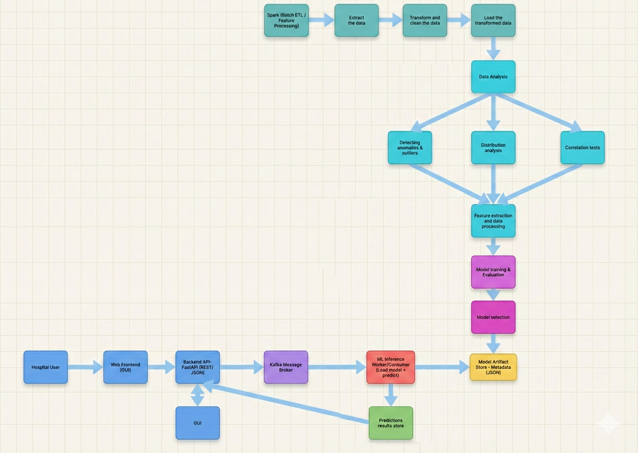
Methodology
